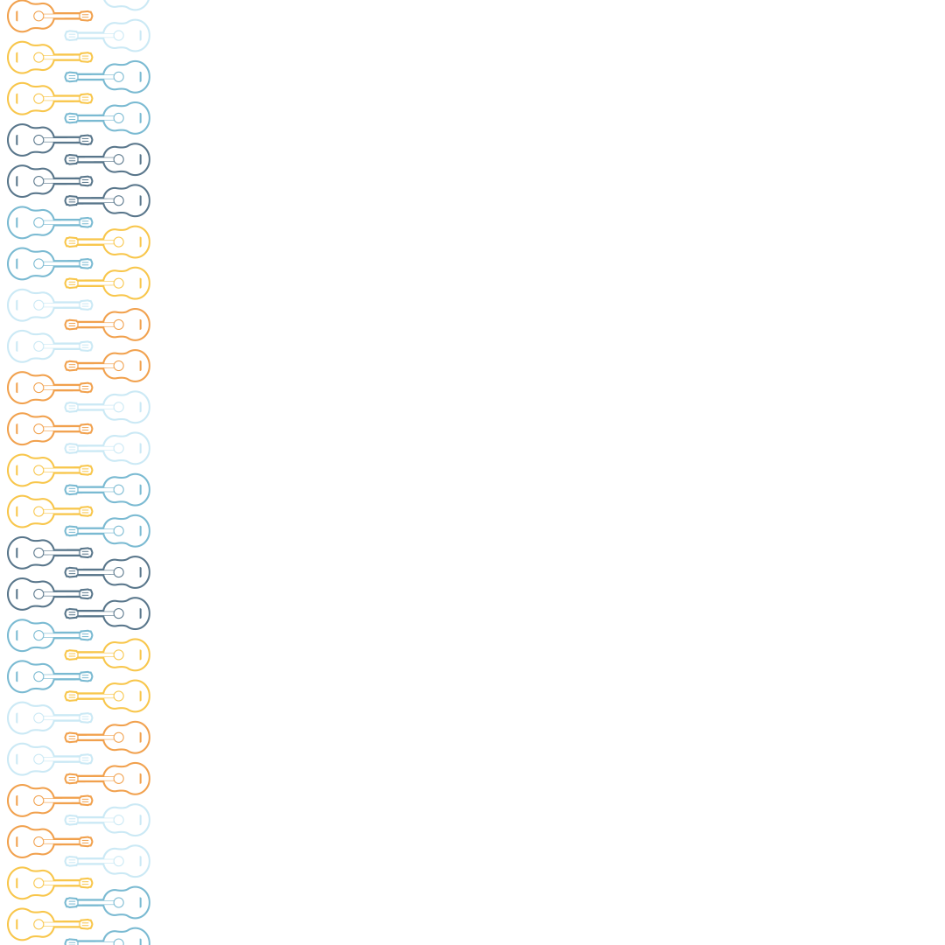
Harmonia Cordis International Youth Guitar Competition 2023 Registration Form:
First Name:
Last Name:
Address:
Country:
Date of Birth:
ID/Passport Number:
Phone Number:
Email:
School/University:
Guitar Teacher:

Competition Category
Category A – 11 years old and younger
Category B – 15 years old and younger
Category C – 19 years old and younger
Competition Program

Privacy Policy:
By entering the competition, you consent to the use of your personal data by the Harmonia Cordis Association for the purposes of administering the Competition and for any other purposes to which you consented during the entry form submission process. The processing of personal data, such as the name, address, e-mail address, or telephone number of a data subject shall always be in line with the General Data Protection Regulation (GDPR 679/14.04.2016), and in accordance with the country-specific data protection regulations applicable to the Harmonia Cordis International Guitar Festival and Competition. Personal data of a competitor will not be published or provided to any third party by the Harmonia Cordis Association.
For any further information, please contact us by email at harmoniacordis@harmoniacordis.org.

